***NATIONAL P.G. COLLEGE***

***PRACTICAL FILE OF***

***FULL STACK WEB DEVELOPMENT TOOLS***



***DEPARTMENT OF DDUKK, SOFTWARE DEVELOPMENT***

***BACHELOR OF VOCATION (B.VOC)***

***SOFTWARE DEVELOPMENT AND E -GOVERNANCE***

***SUBMITTED TO: SUBMITTED BY:***

***Mr. Anees Alam NAME: ADNAN SIDDIQUI***

***Department Of DDUKK, B.VOC ( 5th - SEMESTER)***

***(Software Development & E - Governance) STU_ID : 720642***

***National P.G. College ,***

***Lucknow,***

***SESSION : 2022 – 2023***

***INDEX***

***FULL STACK WEB DEVELOPMENT TOOLS***

|  |  |  |  |
| --- | --- | --- | --- |
| ***Sr.No*** | ***TOPIC*** | ***Pages*** | ***Remark*** |
| **1** | Acknowledgement |  |  |
| **2** | Introduction to Full Stack Web Development |  |  |
| **3** | Full Stack Web Development Tools |  |  |
| **4** | Detailed Explanations of tools   * HTML **/** CSS * BOOTSTRAP * JAVASCRIPT |  |  |
| **5** | Introduction to REACT |  |  |
| **6** | REACT Components |  |  |
| **7** | Project Development Using  HTML / CSS |  |  |
| **8** | Static Website Development Using HTML /CSS |  |  |
| **9** | Project Development Using REACT |  |  |
| **10** | Voice recognition system Using  REACT Library |  |  |
| **11** | To do list Development Using REACT |  |  |
| **12** | Bibliography |  |  |

**Acknowledgement**

In The Accomplishment Of Completion Of My Project On

“ FULL STACK WEB DEVELOPMENT TOOLS ” .

I Would Like To Convey My Special Gratitude To “ ***Mr. Anees Alam Sir*** ”

my Subject Teacher And As Well As

My Classmates.

Your Valuable Guidance And Suggestions Helped Me In Various Phases Of

The Completion Of This Project.

I Will Always Be Thankful To You In This Regard.

I Am Ensuring That This Project Was Finished by Me and Not Copied.

**MOHD ADNAN SIDDIQUI**

**B.Voc (SD & e G)**

**5th Semester**

**Introduction to Full Stack Web Development**

***Meaning of Full Stack Web Development***

* Full stack web developers have the ability to design complete web applications and websites. They work on the frontend, backend, database and debugging of web applications or websites.
* Full stack development refers to web development taking place in both the front and back ends of a website. In other words, the process may involve a combination of underlying database work, user-facing website construction, and client-focused communication aimed at the planning and maintenance of projects (among many other responsibilities).

*•* It refers to the development of both front end(client side) and back end(server side) portions of web application.

**Front End**

* Whenever we see a website, anyone like Google, Facebook, Twitter, Amazon, etc., so what we see on the website is the front end.
* It is the visible part of website or web application which is responsible for user experience. The user directly interacts with the front end portion of the web application or website.

**Front end Languages:** The front end portion is built by using some languages which are:

* HTML (Hyper Text Markup Language)
* CSS (Cascading Style Sheets)
* JavaScript

**Front End Frameworks and Libraries:**

* AngularJs
* React
* Bootstrap
* J Query

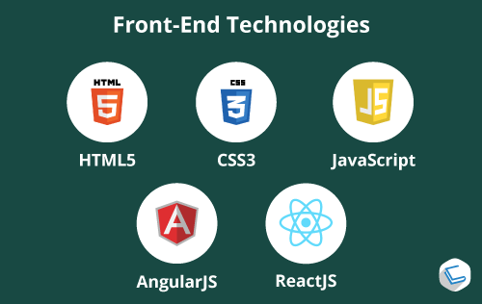

**Back end**

* It refers to the server-side development of web application or website with a primary focus on how the website works.
* It is responsible for managing the database through queries and APIs by client-side commands. This type of website mainly consists of three parts front end, back end, and database.

**Back End Development Languages:** The languages that are used for Back End Development are:

* Java
* Python
* PHP
* Ruby

**Back End Development Databases:**

* MySQL
* Oracle
* MongoDB

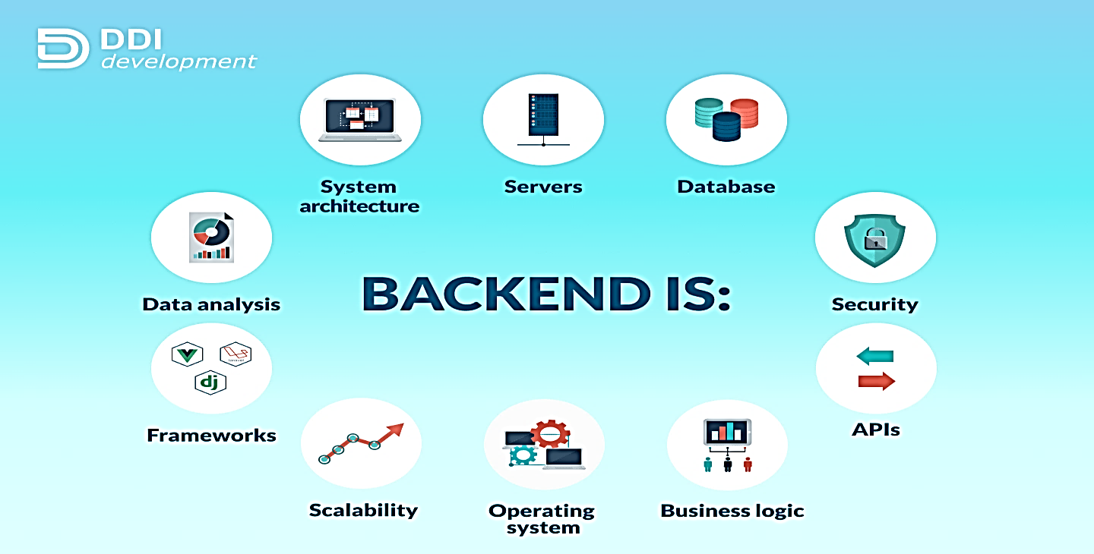

**HTML (Hypertext Markup Language)**

* HTML stands for Hyper text markup language.
* It is responsible for presenting of data on the webpage or browser. It is use to create the static webpages.
* It is non case sensitive language language
* It execute on browser so every html code need browser to execute them (For example Chrome, firefox, Opera)
* It works on behalf of tags (which is open and closed by < > Angular brackets) or its tag based language
* Html describe the structure of webpage
* Html explain the browser how to display the content
* Tim Berner’s Lee is known as the father of HTML.
* The first version of HTML was written by Tim Berners-Lee in 1993.

**Limitation of HTML**

* It provides the basic appearance of the webpage
* Centralized controlling is not there
* It does not provide style like border, margin, padding, transparency .hover effect, removing under line of links, etc

**HTML Tags**

* Tags are predefine keywords for special meaning and purpose every tag has some specific task to perform approx 120 tags has been officially launched 25 tags about to launch
* <html> </html>
* <head> </head>

**Html versions**

1. Html 4.01 1999
2. xHtml 2000
3. HTML 5 2014

**Front –End Development Demo Programme**

<!DOCTYPE html>

<html>

<head>

<title> Demo Programme </title>

</head>

<body>

<h1><b>Career And Future</b></h1>

<h2><b>Focus in Life </b></h2>

<h3><b>Study Smart not hard</b></h3>

<h4><b>Successful life is when it makes you happy too not only to world

</b></h4>

<h5><b>Designed by Adnan Siddiqui </b></h5>

<a>actionsiddiqui@gmail.com</a>

</body>

</html>

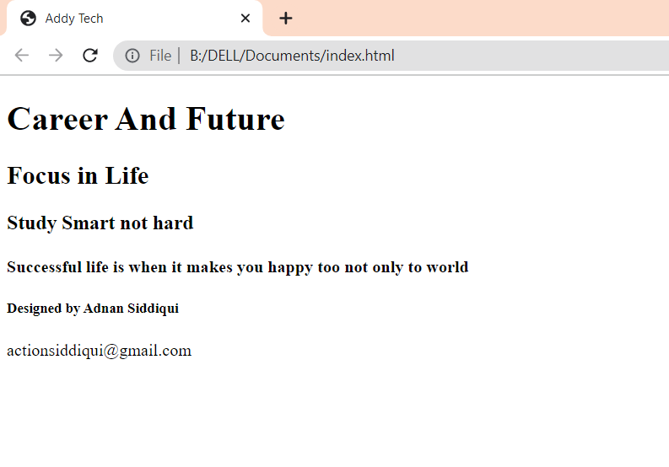

**CSS**

Css provides extra formatting functionality and enhanced the reusability of code css work on html tags. It works with html and javascript. Without css development process is very lengthy and lot of repeated thing we have to include. Suppose a web site containing several webpages so we can make css template and apply on all the pages by changing just one file all the WebPages will be automatically change

* CSS stands for Cascading Style Sheet.
* CSS is used to design HTML tags.
* CSS is a widely used language on the web.
* HTML, CSS and JavaScript are used for web designing. It helps the web designers to apply style on HTML tags.

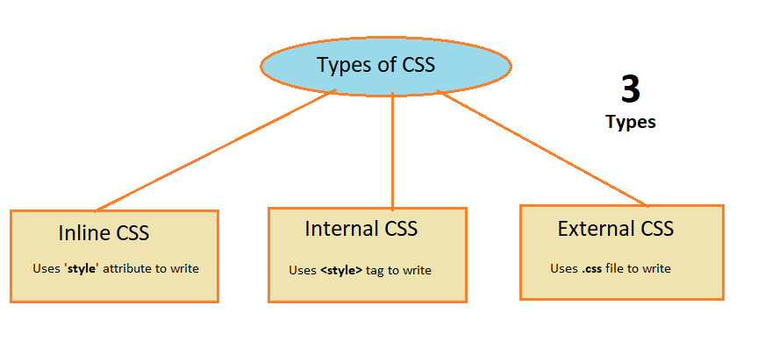

**CSS Demo code -:**

<!DOCTYPE html>

<html lang="en">

<head>

<meta charset="UTF-8">

<meta http-equiv="X-UA-Compatible" content="IE=edge">

<meta name="viewport" content="width=device-width, initial-scale=1.0">

<title>Document</title>

<style>

h1{

color:white;

background-color:red;

padding:5px;

}

p{

color:blue;

font-size: 20px;

background-color: aqua;

}

</style>

</head>

<body>

<h1>Welcome to CSS</h1>

<p>This is Paragraph.</p>

</body>

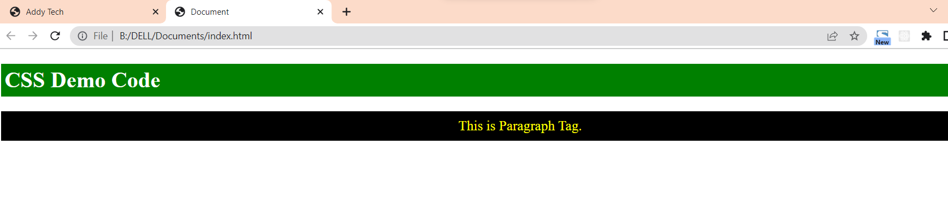</html

**Bootstrap**

* Bootstrap is a free and open-source tool collection for creating responsive websites and web applications.
* It is the most popular HTML, CSS, and JavaScript framework for developing responsive, mobile-first websites.
* Nowadays, the websites are perfect for all browsers (IE, Firefox, and Chrome) and for all sizes of screens (Desktop, Tablets, Phablets, and Phones). All thanks to Bootstrap developers – Mark Otto and Jacob Thornton of Twitter, though it was later declared to be an open-source project.

**Why we use Bootstrap?**

By using this framework we can easily manipulate the styling of any web page, like font style, text color, background color, flex, grid system, etc. Bootstrap Vesrion 4 & Vesrion 5 are the most popular versions.

**Features:**

* It is Faster and Easier way for Web-Development.
* It creates Platform-independent web-pages.
* It creates Responsive Web-pages.
* It designs responsive web pages for mobile devices too.
* It is a free and open-source framework available on www.getbootstrap.com

**How to use Bootstrap on the webpage?**

**Include Bootstrap through CDN links**

### CSS CDN Link

Copy-paste the stylesheet <link> into your <head> before all other stylesheets to load our CSS.

<link href="https://cdn.jsdelivr.net/npm/bootstrap@5.0.2/dist/css/bootstrap.min.css" rel="stylesheet" integrity="sha384-EVSTQN3/azprG1Anm3QDgpJLIm9Nao0Yz1ztcQTwFspd3yD65VohhpuuCOmLASjC" crossorigin="anonymous">

**JS CDN Link**

<script src="https://cdn.jsdelivr.net/npm/bootstrap@5.0.2/dist/js/bootstrap.bundle.min.js" integrity="sha384-MrcW6ZMFYlzcLA8Nl+NtUVF0sA7MsXsP1UyJoMp4YLEuNSfAP+JcXn/tWtIaxVXM" crossorigin="anonymous"></script>

**Javascript**

* Javascript : when user click somewhere on the page then some action should be performed. Client side validation is done by javascript. Timer , alert messages, input box display can be easily done by javascript.
* Scripting Language. JavaScript is a lightweight scripting language made for client-side execution on the browser.
* Interpreter Based.
* Event Handling.
* Light Weight.
* Case Sensitive.
* Control Statements.
* Objects as first-class citizens.
* Functions as First-class citizens(supports functional programming)

**Project Development Using HTML /CSS and JS**

**Static Website Development Using Html/Css , Bootstrap and JS**

**(Client Side View (Browser’s View)**

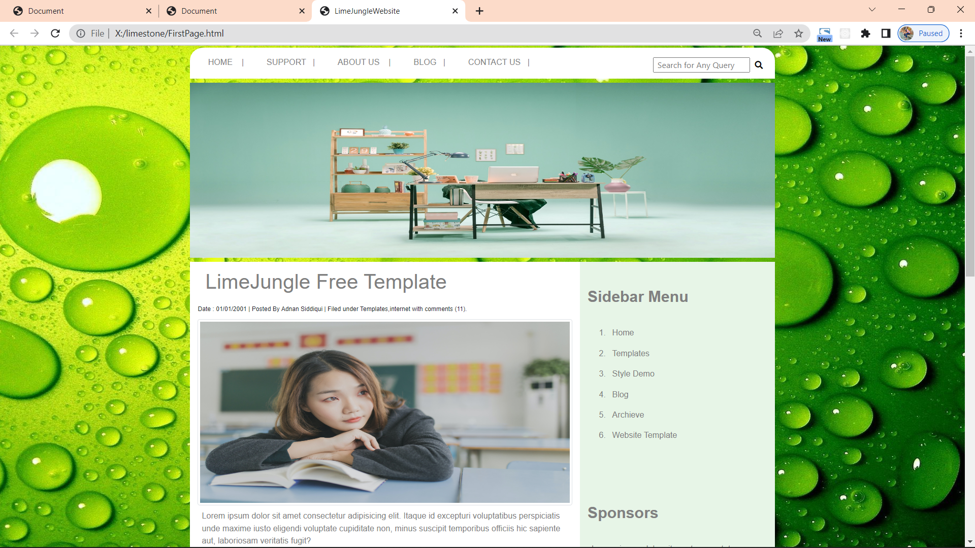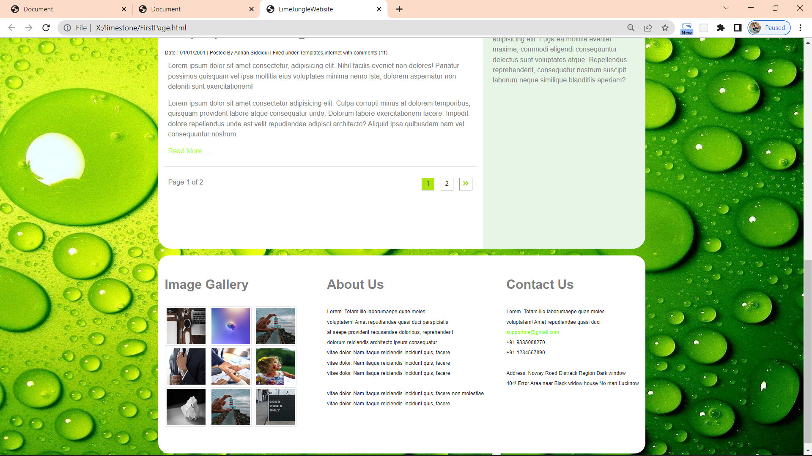

**Source Code**

**<!DOCTYPE html>**

**<html lang="en">**

**<head>**

**<meta charset="UTF-8">**

**<meta http-equiv="X-UA-Compatible" content="IE=edge">**

**<meta name="viewport" content="width=device-width, initial-scale=1.0">**

**<link rel="stylesheet" href="css/all.min.css">**

**<link rel="stylesheet" href="css/bootstrap.min.css">**

**<link rel="stylesheet" href="css/site.css">**

**<link rel="stylesheet" href="css/animate">**

**<title>LimeJungleWebsite</title>**

**</head>**

**<body>**

**<div class="container mt-1">**

**<div class="row" style="border-radius:25px 25px 0px 0px ;">**

**<div class="col-md-12 mt-3 d-md-flex justify-content-between">**

**<div>**

**<a href="#" >HOME &nbsp;&nbsp;&nbsp;|</a>**

**<a href="#" >SUPPORT&nbsp;&nbsp;&nbsp;|</a>**

**<a href="#" >ABOUT US &nbsp;&nbsp;&nbsp;|</a>**

**<a href="#" >BLOG&nbsp;&nbsp;&nbsp;|</a>**

**<a href="#" >CONTACT US&nbsp;&nbsp;&nbsp;|</a>**

**</div>**

**<div>**

**<button class="btn-group mb-2" style="background-color:white;border:2px solid white;">**

**<input type="text" placeholder=" Search for Any Query" >**

**&nbsp;&nbsp;<i class="fa fa-search" aria-hidden="true" style="margin:auto;"></i>**

**</button>**

**</div>**

**<!---END OF COL-->**

**</div>**

**<!---End of row -->**

**</div>**

**<!---End of container-->**

**</div>**

**<section>**

**<div class="container mt-2 " >**

**<div class="row">**

**<div class="col-md-12 p-0">**

**<img src="images/img2.jpg" class="banner img-fluid" alt="banner-image">**

**</div>**

**</div>**

**</div>**

**</section>**

**<section>**

**<div class="container mt-2 mb-3">**

**<div class="row" style="border-radius:0px 0px 30px 30px;">**

**<div class="col-md-8">**

**<h1>**

**LimeJungle Free Template**

**</h1>**

**<span> Date : 01/01/2001 | Posted By Adnan Siddiqui | Filed under Templates,internet with comments (11).</span>**

**<br>**

**<img src="images/img1.jpg" class="img-thumbnail pic" alt="images">**

**<p>Lorem ipsum dolor sit amet consectetur adipisicing elit. Itaque id excepturi voluptatibus perspiciatis unde maxime iusto eligendi voluptate cupiditate non, minus suscipit temporibus officiis hic sapiente aut, laboriosam veritatis fugit?</p>**

**<p style="color:greenyellow;"> Read More ....</p>**

**<br>**

**<hr>**

**<br>**

**<h1> Laptop in meeting room</h1>**

**<span> Date : 01/01/2001 | Posted By Adnan Siddiqui | Filed under Templates,internet with comments (11).</span>**

**<p>Lorem ipsum dolor sit amet consectetur, adipisicing elit. Nihil facilis eveniet non dolores! Pariatur possimus quisquam vel ipsa mollitia eius voluptates minima nemo iste, dolorem aspernatur non deleniti sunt exercitationem!</p>**

**<p>Lorem ipsum dolor sit amet consectetur adipisicing elit. Culpa corrupti minus at dolorem temporibus, quisquam provident labore atque consequatur unde. Dolorum labore exercitationem facere. Impedit dolore repellendus unde est velit repudiandae adipisci architecto? Aliquid ipsa quibusdam nam vel consequuntur nostrum.</p>**

**<br>**

**<p style="color:greenyellow;"> Read More ....</p>**

**<hr>**

**<p> Page 1 of 2</p>**

**<div style="float:right;">**

**<div style="border:1px solid rgb(150, 150, 150); width:30px;height:30px;background-color:rgb(172, 228, 19);color:rgb(0, 0, 0);text-align: center;display: inline-block;margin:10px;"> 1 </div>**

**<div style="border:1px solid rgb(125, 125, 125); width:30px;height:30px;display: inline-block;text-align: center;"> 2 </div>**

**<div style="border:1px solid rgb(150, 150, 150);width:30px;height:30px;display: inline-block;margin:10px;text-align: center;"><i class="fa fa-angle-double-right" style="color:rgb(167, 215, 8);"></i></div>**

**</div>**

**</div>**

**<div class="col-md-4" style="background-color: rgb(231, 245, 231);border-radius:0px 0px 30px;">**

**<h2> Sidebar Menu</h2>**

**<br>**

**<ol>**

**<li>Home</li>**

**<li>Templates</li>**

**<li> Style Demo</li>**

**<li> Blog</li>**

**<li> Archieve</li>**

**<li> Website Template</li>**

**</ol>**

**<br>**

**<br>**

**<h2>Sponsors</h2>**

**<br>**

**<p>Lorem, ipsum dolor sit amet consectetur adipisicing elit. Hic mollitia modi officia placeat iusto quas quaerat molestiae, earum enim eos doloribus omnis ducimus itaque est vero magni harum? Laborum, placeat.</p>**

**<p>Lorem ipsum dolor sit amet consectetur adipisicing elit. Fuga ea mollitia eveniet maxime, commodi eligendi consequuntur delectus sunt voluptates atque. Repellendus reprehenderit, consequatur nostrum suscipit laborum neque similique blanditiis aperiam?</p>**

**</div>**

**</div>**

**</div>**

**</section>**

**<section>**

**<div class="container">**

**<div class="row" style="border-radius:25px;">**

**<div class="col-md-12 d-md-flex justify-content-between">**

**<div>**

**<h2> Image Gallery</h2>**

**<br>**

**<img src="images/img3.jpg" class="gallery img-thumbnail" alt="gallery Image">**

**<img src="images/img5.jpg" class="gallery img-thumbnail" alt="gallery Image">**

**<img src="images/img4.jpg" class="gallery img-thumbnail" alt="gallery Image">**

**<br>**

**<img src="images/img8.jpg" class="gallery img-thumbnail" alt="gallery Image">**

**<img src="images/img10.jpg" class="gallery img-thumbnail" alt="gallery Image">**

**<img src="images/img9.jpg" class="gallery img-thumbnail" alt="gallery Image">**

**<br>**

**<img src="images/img6.jpg" class="gallery img-thumbnail" alt="gallery Image">**

**<img src="images/img4.jpg" class="gallery img-thumbnail" alt="gallery Image">**

**<img src="images/img7.jpg" class="gallery img-thumbnail" alt="gallery Image">**

**<br>**

**</div>**

**<div>**

**<h2> About Us </h2>**

**<br>**

**<span>Lorem. Totam illo laborumaepe quae moles**

**<br>voluptatem! Amet repudiandae quasi duci**

**perspiciatis**

**<br>at saepe provident recusandae doloribus,**

**reprehenderit**

**<br> dolorum reiciendis architecto ipsum consequatur</span>**

**<span>**

**<br>vitae dolor. Nam itaque reiciendis</span>**

**<span>incidunt quis, facere</span>**

**<span>**

**<br>vitae dolor. Nam itaque reiciendis</span>**

**<span>incidunt quis, facere</span>**

**<span>**

**<br>vitae dolor. Nam itaque reiciendis</span>**

**<span>incidunt quis, facere</span>**

**<br>**

**<span>**

**<br>vitae dolor. Nam itaque reiciendis</span>**

**<span>incidunt quis, facere</span>**

**<span>non molestiae**

**<br>vitae dolor. Nam itaque reiciendis</span>**

**<span>incidunt quis, facere</span>**

**</div>**

**<div>**

**<h2> Contact Us </h2>**

**<br>**

**<span>Lorem. Totam illo laborumaepe quae moles**

**<br>voluptatem! Amet repudiandae quasi duci**

**</span>**

**<br>**

**<span style="color:chartreuse;">supportme@gmail.com</span>**

**<br>**

**<span>+91 9335088270</span>**

**<br>**

**<span> +91 1234567890</span>**

**<br>**

**<br>**

**<span>**

**Address: Noway Road Distrack Region Dark window**

**<br> 404! Error Area near Black widow house No man Lucknow**

**</span>**

**</div>**

**</div>**

**</div>**

**<br>**

**</div>**

**</section>**

**</body>**

**</html>**

**REACT**



**What is React?**

* React, sometimes referred to as a frontend JavaScript framework, is a JavaScript library created by Facebook
* React is a tool for building UI components.
* React is a JavaScript library for building user interfaces.
* React is used to build single-page applications.
* React allows us to create reusable UI components.
* React only changes what needs to be changed!
* Current version of React.JS is V18.0.0 (April 2022).
* Initial Release to the Public (V0.3.0) was in July 2013.

1. **What is JSX?**

* JSX stands for JavaScript XML.
* JSX allows us to write HTML in React.
* JSX makes it easier to write and add HTML in React.

**Expressions in JSX**

With JSX you can write expressions inside curly braces { }.

The expression can be a React variable, or property, or any other valid JavaScript expression.

**EXAMPLE**

const myElement = <h1>React is {5 + 5} times better with JSX</h1>;

**Example 2**

const myElement = (

< >

<p>I am a paragraph.</p>

<p>I am a paragraph too.</p>

</>

**Create React App**

To learn and test React, you should set up a React Environment on your computer.

The create-react-app tool is an officially supported way to create React applications.

**" npx create-react-app my-react-app "**

**3 Step Process run these commands**

* **npx create-react-app demoapp**
* **cd demoapp**
* **npm start**

**React Components**

Components are independent and reusable bits of code. They serve the same purpose as JavaScript functions, but work in isolation and return HTML.

Create Your First Component

When creating a React component, the component's name MUST start with an upper case letter.

**Class Component**

A class component must include the extends React.Component statement. This statement creates an inheritance to React.Component, and gives your component access to React.Component's functions.

The component also requires a render() method, this method returns HTML.s

Example

Create a Class component called Car

class Car extends React.Component {

render() {

return <h2>Hi, I am a Car!</h2>;

}

}

**Function Component**

A Function component also returns HTML, and behaves much the same way as a Class component, but Function components can be written using much less code, are easier to understand, and will be preferred in this tutorial.

Example

Create a Function component called Car

function Car() {

return <h2>Hi, I am a Car!</h2>;

}

**Demo of react component**

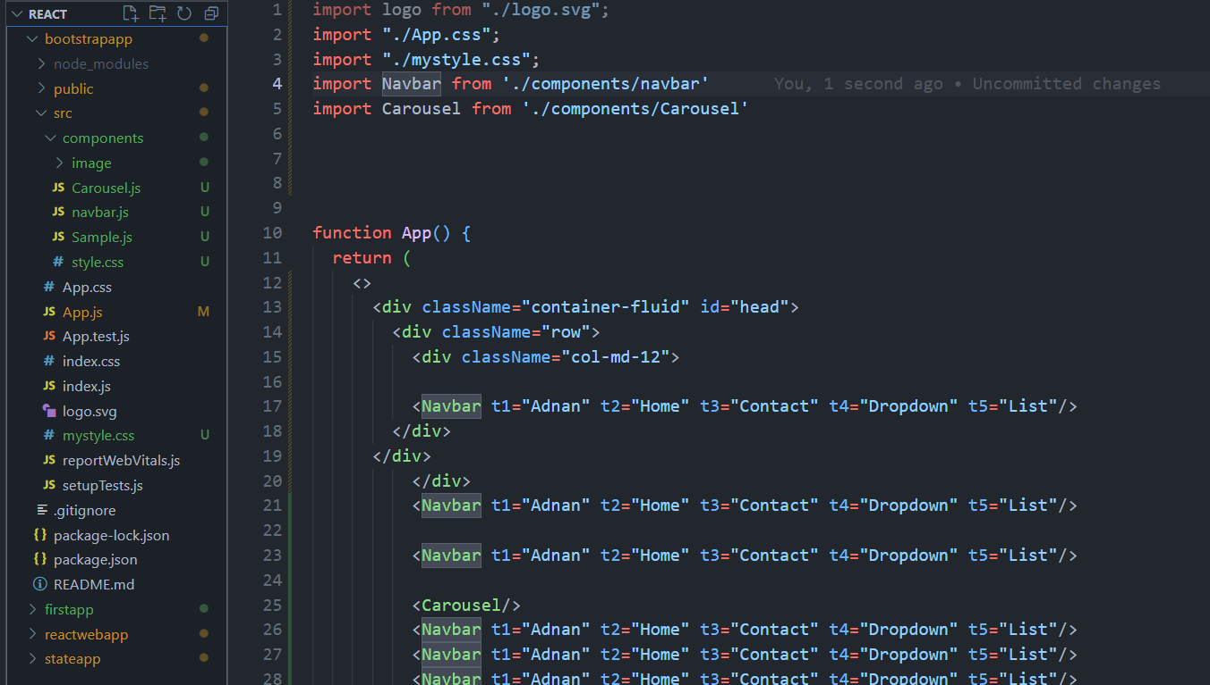

**React Component Folder**

## 

**Project Development Using REACT**

**Speech Recognition app in react**

There are lot of major functionality of speech recognition but few of them like

1. Transcript it understand what we are speaking and convert into text and display on screen

2. ResetTranscript means it will remove all the types matter on screen

**Command to install the important packages**

npm install --save react-speech-recognition

cmd Window

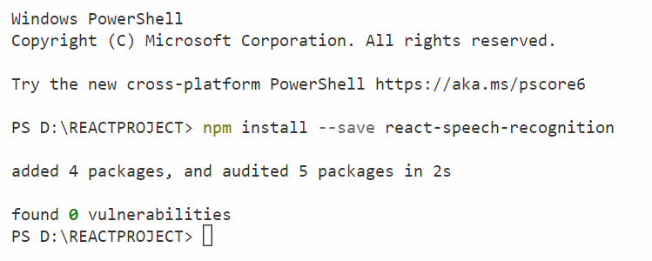

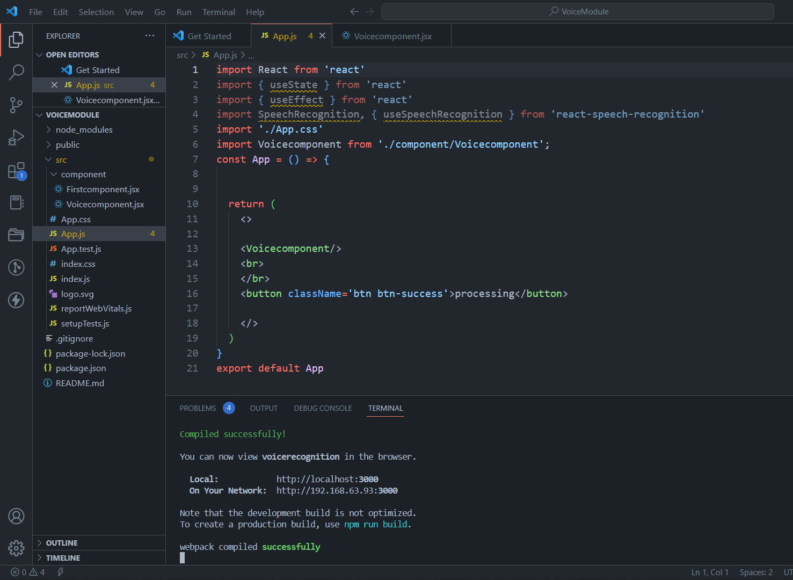

**Component**

**( Voice Module JS file )**

**CSS file of Voice Module**

**Imported in App.js**

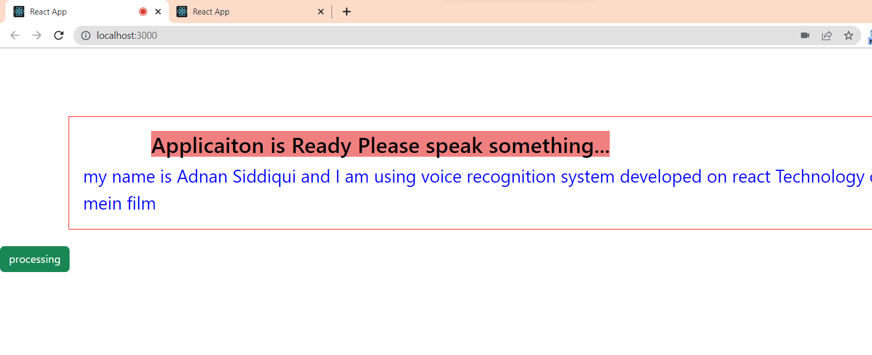Source Code of App.js

import React from 'react'

import { useState } from 'react'

import { useEffect } from 'react'

import SpeechRecognition, { useSpeechRecognition } from 'react-speech-recognition'

import './App.css'

import Voicecomponent from './component/Voicecomponent';

const App = () => {

return (

<>

<Voicecomponent/>

<br>

</br>

<button className='btn btn-success'>processing</button>

</>

)

}

export default App

**CSS used in Voice Module App**

body {

margin: 0;

font-family: -apple-system, BlinkMacSystemFont, 'Segoe UI', 'Roboto', 'Oxygen',

'Ubuntu', 'Cantarell', 'Fira Sans', 'Droid Sans', 'Helvetica Neue',

sans-serif;

-webkit-font-smoothing: antialiased;

-moz-osx-font-smoothing: grayscale;

}

code {

font-family: source-code-pro, Menlo, Monaco, Consolas, 'Courier New',

monospace;

}

**Code of Voice Component**

import React from 'react'

import SpeechRecognition, { useSpeechRecognition } from 'react-speech-recognition'

const Voicecomponent = () => {

const commands = [

{

command: 'reset',

callback:({resetTranscript})=>{

resetTranscript();

}

},

{

command: 'clear',

callback:({resetTranscript})=>{

resetTranscript();

}

},

{

command:'open *',

callback:(site)=>{window.open('http://'+ site)}

},

{

command: 'increase text size',

callback:()=>{document.getElementById('content').fontSize='24px'}

},

{

command: 'decrease text size',

callback:()=>{document.getElementById('content').fontSize='16px'}

},

{

command: 'change text to *',

callback:(color)=>{document.getElementById('content').style.Color=color}

},

{

command: 'clear',

callback: ({ resetTranscript }) => resetTranscript()

}

]

SpeechRecognition.startListening({continuous: true,language:'en-IN'})

// In the above example continous true means continoulsy we can speak

// and application will. language = en-IN means it will be in indian

// lanaguage

const {transcript, browserSupportsSpeechRecognition } = useSpeechRecognition({ commands })

if (!browserSupportsSpeechRecognition) {

alert('Your browser is not supporting voice command')

return null

}

return (

<div className="container">

<div className="nav">

<h2>Applicaiton is Ready Please speak something...</h2>

</div>

<div id="content">

{transcript}

</div>

</div>

)

}

export default Voicecomponent;

**Project 2**

**Task Todo List Using React**

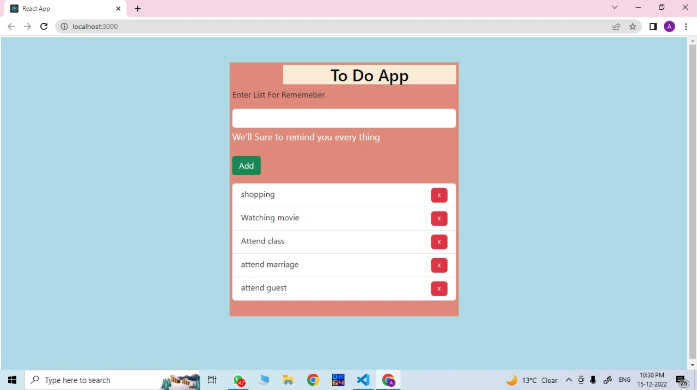

**Source Code of App.js**

import logo from './logo.svg';

import React, { useEffect, useState } from 'react';

import './App.css';

import './mycss.css';

function App() {

const [listitem, updatelist] = useState([]);

const [todo, setTodo] = useState("");

function AddItem(e) {

e.preventDefault();

updatelist([...listitem,todo])

setTodo("")

}

return (

<>

<div className="container-fluid background">

<div className="Row ht"></div>

<div className="row">

<div className="col-sm-4">

</div>

<div className="col-sm-4 center">

<h2>To Do App</h2>

{/* inputfield */}

<form>

<div className="mb-3">

<label for="exampleInputEmail1" className="form-label mb-3">Enter List For Rememeber</label>

<input type="text" value={todo} className="form-control" id="text" onChange={(e) => { setTodo(e.target.value) }} />

<div id="emailHelp" className="form-text fcolor">We'll Sure to remind you every thing</div>

<br>

</br>

<button className="btn btn-success" onClick={(e) => AddItem(e)}>Add</button>

</div>

</form>

{/* input field close */}

<ul className="list-group">

{

listitem.map(item => {

return <li key={item} className="list-group-item">{item}</li>

})

}

</ul>

</div>

<div className="col-sm-4">

{/* Last Extra div */}

</div>

</div>

</div>

</>

);

}

export default App;

**CSS File**

body

{

background-color: rgb(215, 235, 223);

}

.card{

width:600px;

height: 600px;

margin: auto;

margin-top:100px;

background-image: url(./images/todo.jpg);

background-position: bottom right;

background-size:400px 400px;

background-repeat :no-repeat;

box-shadow: 5px 5px black;

}

#list

{

width:100%;

height: 100%;

display: inline-block;

text-align: left;

}

**BIBLIOGRAPHY**

In the excellency of this Project a sort of things helped me

**WEBSITES USED**

* **REACT Documentation site**

[**https://reactjs.org/docs/getting-started.html**](https://reactjs.org/docs/getting-started.html)

* **W3School. Org**

[**https://www.w3schools.com/html/html_scripts.asp**](https://www.w3schools.com/html/html_scripts.asp)

**BOOKS USED**

* **Learning PHP, MySQL & JavaScript: With jQuery, CSS & HTML5**
* **Web Design With HTML, CSS, JavaScript and jQuery Set**
* **JavaScript: The Definitive Guide**